**WIA1002 Tutorial 11**

**Binary Search Tree**

1. What is a binary search tree (BST)?

ANSWER: A tree with each node has at most 2 children.

**Answer: A BST is a special type of binary tree, which has the property that for every node in the tree the value of any node in its left subtree is less than the value of the node and the value of any node in its right subtree is greater than the value of the node.**

1. Build a BST based on the input 50, 30, 25, 71, 80, 99, 40, 1, 7, 5. Draw the final tree.

ANSWER:

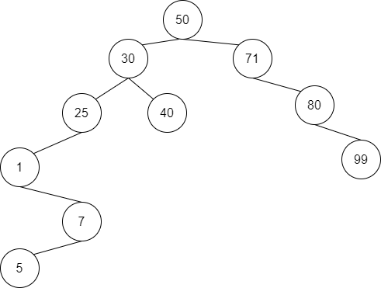



3. What is the height of the tree built in Question 2?

ANSWER:

5

1. Given the following BST, list the items in the order of:

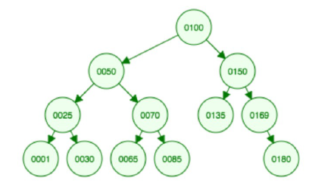

(a) Pre-order traversal

(b) In-Order traversal

(c) Post-order traversal

ANSWER:

1. 0100, 0050, 0025, 0001, 0030, 0070, 0065, 0085, 0150, 0135, 0169, 0180
2. 0001, 0025, 0030, 0050, 0065, 0070, 0085, 0100, 0135, 0150, 0169, 0180
3. 0001, 0030, 0025, 0065, 0085, 0070, 0050, 0135, 0180, 0169, 0150, 0100
4. Using the same BST in Question 4, delete the element `0030’. Draw the resulting tree.

ANSWER:





6. Again, using the same BST in Question 3 (i.e., ignoring the deletion of `0030’ in Question 5), delete the element `0050’. Draw the resulting tree.

ANSWER:



